# Parking Management System

**A Report**

**Submitted in partial fulfillment of the requirements for the Final Project Sem**

**of**

## Master of Computer Application

By

**Shivam Kaushal(231222391641)**

**Devesh Kumar(231222391602)**



Department of Computer Applications UIET

CSJM University Kanpur

2023-24

University Institute of Engineering and Technology

CSJM University Kanpur

## Department of Computer Applications

**CERTIFICATE** Date: 14 Dec 2023

*This is to certify that the report of project work entitled* ***(Parking Management System)*** *is being submitted by* ***(Shivam kaushal 641)*** *and* ***(Devesh Kumar 602)*** *in partial fulfillment of the requirements for the Final Year Project of (departmentname) to the University Institute of Engineering & Technology, CSJM University, Kanpurduring the academic year 2023-24 is a record of bonafide work carried out by him under our guidance and supervision.*

*The results embodied in this report have not been submitted by the student(s) to anyother University or Institution for the award of any degree or diploma.*

**Internal Guide Head of Department**

**Mr. Akhilesh Singh Dr. Robins Porwal**

ACKNOWLEDGEMENT

I express my deep sense of gratitude to my **Director (**University Institute of Engineering and Technology**)** for thevaluable guidance and for permitting us to carry out this project.

.

With gratitude,

1. Shivam Kaushal
2. Devesh Kumar

# CONTENTS

## Name Page

* 1. Introduction Of Project
  2. Objective Of The Project
  3. Scope Of The Project
  4. Project Plan
  5. The Existing System
  6. Background Of The Organization
  7. Current Problems
  8. Areas For Improvement
  9. Proposed System
  10. Input/output Requirement
  11. Hardware And Software Requirement
  12. Database Requirement
  13. Software Requirement Specification
  14. Database Dictionary
  15. E-R Diagram
  16. Security Control
  17. Screen Shots
  18. Validation Checks
  19. Testing
  20. Implementation and Maintenance **22.**Future Scope Of The Project **23.**Conclusion

Points to be considered while submission of project

1.

The cover page must be hard bound in Black Color; with Gold Embossing .

2.

The size of the report would depend on the project undertaken. However it must be 120 - 150 typed pages (Single space) on A4 size paper.

3.

All the students are required to use the uniform font and format (except in heading and subheadings) throughout the text of the report. For example, if anybody uses “Times New Roman” of font size 12 in the text, then he/she will be using the same throughout the report.

4.

The report (at the time of submission) should have the following page margins: Top and Bottom edge : 25 mm (1inches) Left and right side : 32 mm (1.25inches)

All page numbers should be typed at the center of page at the bottom. 5.

The project report must accompany a certificate authenticating the originality of the work done in the prescribed format, as indicated below.

6.

The student is required to submit TWO hard copies of the project report hardly bound in BLACK color hard rexin binding with goldenengraved letters and two soft copies on CD (full source code in working condition).

7.

Along with this, students will keep one copy of the project for their further reference in future and one copy to the organization where they have done their training (if required).

8.

There should not be any deviation from the Cover page as given in the format prescribed .

9.

Letter of Authentication should be submitted by students declaring that the Project Report is the original work of student and no reward had been attained for same project ever before. Students are advised not to COPY the project report from other students.

10.

Authorization from Organization / Institute/ University/ where such Project have been implemented should be added with certificate showing the student name, project name with future recommendations of organization if any.

11.

Certificate from the Project Guide certifying the project work done under his/her guidance along with course, student name & project details complete in all respects.

12.

PPT(Power Point Presentation) must be prepared.

# INTRODUCTION

The project **“parking management system”** is based on an Problem that arrives in local bodies, cities, public places, Streets, etc...

This project is to solve the basic problem of management of parking system present in any public place.

It can create a big database of entry & exit of vehicle as well as show how many slots are available for the next coming vehicle.

Even it can change also the vehicle of rate per/ hour.

We can manipulate the size of parking slots as per the space available for the user.

This project is based on parking problems

We have used **“Python Programming”** along with **“DBMS”** to store data in system.

This application is being created by coiling views of me & our team with the guidance of our teacher.

Our project is further too explained in the whole document present forwardly.

Drivers searching for parking are estimated to be responsible for about 30% of traffic congestion in cities. Historically, cities, businesses, and property developers have tried to match parking supply to growing demand for parking spaces. It has become clear, though, that simply creating more parking spaces is not sufficient to address the problem of congestion. New approaches using smart parking systems look to provide a more balanced view of parking that better manages the relationship between supply and demand.

A number of technologies provide the basis for smart parking solutions, including vehicle sensors, wireless communications, and data analytics. Smart parking is also made viable by innovation in areas such as smartphone apps for customer services, mobile payments, and in-car navigation systems. At the heart of the smart parking concept is the ability to access, collect, analyze, disseminate, and act on information on parking usage. Increasingly, this information is provided in real-time from intelligent devices that enable both parking managers and drivers to optimize the use of parking capacity

# OBJECTIVE OF PROJECT

The main objective of our project is to solve the problem regarding parking of vehicle & the charges which are the paid by the user for the parking.

The objective is to store the parking data in a proper form which is unsynchronized and unstable.

The objective is to create a proper function for the parking in every public place.

The system retrieves data & gives all data as per need for any enquiry or for any use.

Many new revenue streams are possible with smart parking technology. For example, lot owners can enable tiered payment options dependent on parking space location. Also, reward programs can be integrated into existing models to encourage repeat users.

Returning users can replace daily, manual cash payments with account invoicing and application payments from their phone. This could also enable customer loyalty programs and valuable user feedback

More automation and less manual activity saves on labor cost and resource exhaustion.

Traffic flow increases as fewer cars are required to drive around in search of an open parking space.

# SCOPE OF THE PROJECT

1. **Optimized parking** – Users find the best spot available, saving time, resources and effort. The parking lot fills up efficiently and space can be utilized properly by commercial and corporate entities.
2. **Reduced traffic** – Traffic flow increases as fewer cars are required to drive around in search of an open parking space.
3. **Reduced pollution** – Searching for parking burns around one million barrels of oil a day. An optimal parking solution will significantly decrease driving time, thus lowering the amount of daily vehicle emissions and ultimately reducing the global environmental footprint.
4. **Enhanced User Experience** – A smart parking solution will integrate the entire user experience into a unified action. Driver’s payment, spot identification, location search and time notifications all seamlessly become part of the destination arrival process.
5. **New Revenue Streams** – Many new revenue streams are possible with smart parking technology. For example, lot owners can enable tiered payment options dependent on parking space location. Also, reward programs can be integrated into existing models to encourage repeat users.
6. **Integrated Payments and POS** – Returning users can replace daily, manual cash payments with account invoicing and application payments from their phone. This could also enable customer loyalty programs and valuable user feedback.
7. **Increased Safety** – Parking lot employees and security guards contain real-time lot data that can help prevent parking violations and suspicious activity. License plate recognition cameras can gather pertinent footage. Also, decreased spot-searching traffic on the streets can reduce accidents caused by the distraction of searching for parking.
8. **Real-Time Data and Trend Insight** – Over time, a smart parking solution can produce data that uncovers correlations and trends of users and lots. These trends can prove to be invaluable to lot owners as to how to make adjustments and improvements to drivers.
9. **Decreased Management Costs** – More automation and less manual activity saves on labor cost and resource exhaustion.

# IDENTIFICATION OF NEED

The old manual system was suffering from a series of drawbacks. Since whole of the system was to be maintained with hands the process of keeping, maintaining and retrieving the information was very tedious and lengthy. The record were never used to be in a systematic order. There used to be lots of difficulties in associating any particular truncation with a particular context. If any information was to be found it was required to go through the different registers, documents there would never exist anything like report generation.

There would always be unnecessary consumption of time while entering records and retrieving records. One more problem was that it was very difficult to find errors while entering the records. Once the records were entered it was very difficult to update these records.

The reason behind it is that there is lot of information to be maintained and have to be kept in mind while running the business. For this reason we have provided features

present system is partially automated (computerized), actually existing system is quite laborious as one has to enter same information at three different places.

# Following points should be well considered:

* Documents and reports that must be provided by the new system : there can also be few reposts , which can help management in decision- making and cost controlling, but

since these reposts do not get required attention, such kind of reports and information were also identified and given required attention.

* Detailed of the information needed for each document and report.
* The required frequency and distribution for each document.
* Probable source of information for each document and report.
* With the implementation of computerized system, the task of keeping records in a organized manner will be solved. The greatest of all is the retrieval of information, which will be at

the click of the mouse. So the proposed system helps in saving the time in different operations and making information flow easy giving valuable reports

# Project Plan (Initial Phase)

The base structure plan is to make it available all the local body to maintain their parking for customer so, that customer gets ease to take services from them.

Their parking program can be implemented in colleges, multiplexes, markets, open market, fair, road parking etc.

At very compact places it can manage & schedule space to vehicle owner so that they can park there vehicle at low cost with full safety of the vehicle.

Parking system, as described above, can lead to error free, secure, reliable and fast management system. It can assist the user to concentrate on their other activities rather to concentrate on the record keeping. Thus it will help organization in better utilization of resources.

The organization can maintain computerized records without redundant entries. That means that one need not be distracted by information that is not relevant. While being able to reach the information.

The aim is to automate its existing manual system by the help of computerized equipment’s and full-fledged computer software, fulfilling their requirements, so that their valuable data/information can be stored for a longer period with easy accessing and manipulation of the same.

Basically the project describes how to manage for good performance and better services for the clients.

# The Existing System

Most of the parking lot have parking system which is based on the pen & paper system, which is not easy.

User takes there paper or token in which token no. is provided but it cannot tells how much vehicle are available to for parking and how many vehicle are parked and where parked.

So the whole system needs to be upgraded.

Existing system cannot be utilized in occasional like in public fair but this system can be available at every public place.

In the existing system the exams are done only manually but in proposed system we have to computerize the exams using this application.

* + Lack of security of data
  + More man power.
  + Time consuming.
  + Consumes large volume of pare work.
  + Needs manual calculations
  + No direct role for the higher officials.

# REPORTS OF PARKING SYSTEM

* + It generates the report on parking slots, vehicles, customers.
  + Provide filter reports on parking fees, duration, types.
  + You can easily export PDF for the parking slots, customers, duration.
  + Application also provides excel export for vehicles , parking fees, types
  + You can also export report into csv format for parking slots, vehicles, types.

# USER INTERFACE DESIGN

User interface design is concerned with the dialogue between a user and the computer. It is concerned with everything form starting the system the system or logging into the system to the eventually presentation of desired inputs and outputs. The overall flow of screens and messages is called a dialogue.

# The following steps are various guidelines for user interface design

* 1. The system user should always be aware of what to do next.
  2. The screen should be formatted so that various types of information, instructions and messages always appear in the same general display area.
  3. Message, instructions or information should be displayed long enough to allow the system user to read them.
  4. Use display attributes sparingly.
  5. Default values for fields and answer to be entered by the user should be specified.
  6. A user should not be allowed to proceed without correcting an error.
  7. The system user should never get an operating system message or fatal error.

# PROPOSED SYSTEM

The aim of proposed system is to develop a system of improved facilities. The proposed system can overcome all the limitations of the existing system. The system provides proper security and reduces the manual work.

* Security of data.
* Ensure data accuracy’s
* Proper control of the higher officials.
* Minimum time needed for the various processing.
* Greater efficiency
* Better service.
* User friendliness and interactive.
* Minimum time required.

# I/O Requirements

As we all know about of our project it can take multiple entries.

This program can be identified too acc. To user capacity of storing vehicle.

It can consist a number, characters combination of both as vehicle number.

It asks user to book slot accordingly to him & find the vacant parking as that can be seen in figures and images.

When the user enters its details which are like name, vehicle number, etc..

The length of name can be as long as 1000 character & vehicle number also same as it can consist as long as 10 to 15 character & number combination.

# INPUT DATA AND VALIDATION OF PROJECT ON PARKING SYSTEM

* All the fields such as parking slots , parking fees , types are validated and does not take invalid values
* Each form for parking slots, vehicles, customers cannot accept blank value fields.
* Avoiding errors in data
* Controlling amount of input
* Integration of all the modules/forms in the system.
* Preparation of the test cases.
* Preparation of the possible test date with all the validation checks.
* Actual testing done manually.
* Recording of all the reproduced errors.
* Modifications done for the errors found during testing.
* Prepared the test result scripts after rectification of the errors.
* Functionality of the entire module/forms.
* Validations for user input.
* Checking of the coding standards to be maintained during coding.
* Testing the module with all the possible test data.

# SOFTWARE REQUIREMENT SPECIFICATION

The software requirements specification is produced at the culmination of the analysis task. The function and performance allocated to software as part of system engineering are refined by establishing a complete information description, a detailed functional and behavioral description , an indication of performance requirements and design constraints, appropriate validation criteria, and other data pertinent to requirements.

# THE PROPOSED SYSTEM HAS THE FOLLOWING REQUIREMENTS:

* System needs store information about new entry of parking slots.
* System needs to help the internal staff to deep information of vehicles and find them as per various queries.
* System need to maintain quantity record.
* System need to deep the record of parking fees.
* System need to update and delete the record.
* System also needs a search area.
* It also needs a security system to prevent data.

|  |  |
| --- | --- |
| Language | C language |
|  |  |
|  |  |
|  |  |
|  |  |
|  |  |
|  |  |

# CONCUSION OF THE PROJECT

Our project is only a humble venture to satisfy the needs to manage their project work. Several user friendly coding have also adopted. This package shall prove to be a powerful package in satisfying all the requirements of the school. The objective of software planning is to provide a frame work that enables the manger to make reasonable estimates made within a limited time frame at the beginning of the software project should be updated regularly as the project progresses.

# AT THE END IT IS CONCLUDED THAT WE HAVE MADE EFFORT ON FOLLOWING POINTS:

* A description of the background and context of the project and its relation to work already done in the area.
* Made statement of the aims and objectives of the project.
* The description of purpose, scope and applicability.
* We define the requirement specifications of the system and the actions that can be done on these things,
* We understand the problem domain and produce a model of the system, which describes operation that can be performed on the system.
* We included features and operations in detail, including screen layouts.
* We designs user interface and security issues related to system.
* Finally the system is implemented and tested according to test cases.

# Current Problem

In the modern society, there is an ever-increasing number of vehicles. This is leading to problems such as large urban parking lots becoming inefficient, increasing difficulty to find open spaces in busy parking lots, as well as the increasing need to devote larger areas of land for additional parking spaces. One may ask, why are these problems significant?

## Problem Statement:

The three main problems that the increasing number of vehicles and the decreasing efficiency of modern busy parking lots are:

## Valuable time wasted from inconvenient and inefficient parking lots

* + On average, 3.5-12 minutes spent waiting for a spot in urban parking lots.

# More fuel consumed while idling or driving around parking lots, leading to more CO2 emission being produced

* + Average distance traveled looking for a spot = 1.2km
  + Average CO2 produced per car per day = .14 kg CO2

# Maintenance

System Maintenance is a modification of the software product after delivery to accomplish one of the following objectives:

* + Correct faults.
  + Improve the performance or other attributes
  + Adapt the product to the change environment

The term support and maintenance describes activity that occur after a system is made operational. Support activities assist users in realizing the full benefits of the system. It ensures that the system function at peak efficiency and the needed changes are implemented with minimal disruption to the organization.

The performance of the system can be measured by two factors, viz. the efficiency and effectiveness. The efficiency indicates the manner in which the inputs are used by the system .If the input-output ratios is adverse, we say that the system is inefficient though it produces the desired output or not .When the system is ineffective, the system is out of control and it needs a major correction. A system has to be effectiveness is a measure of the productivity i.e. the measure of the output against the input.

Throughout the Lifecycle of the project it is put through test against efficiency and effectiveness quite frequently. The stronger the system is, the lesser maintenance the system requires. As of now, there is no significant maintenance policy adopted or proposed for the system.

# Screenshots

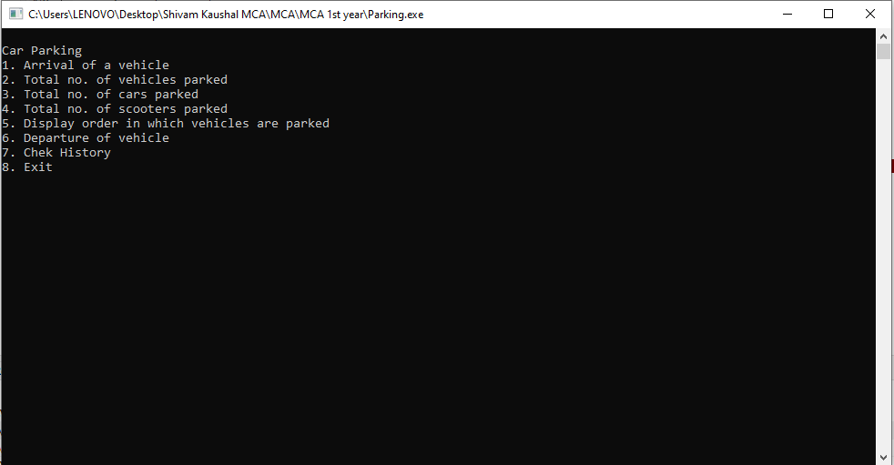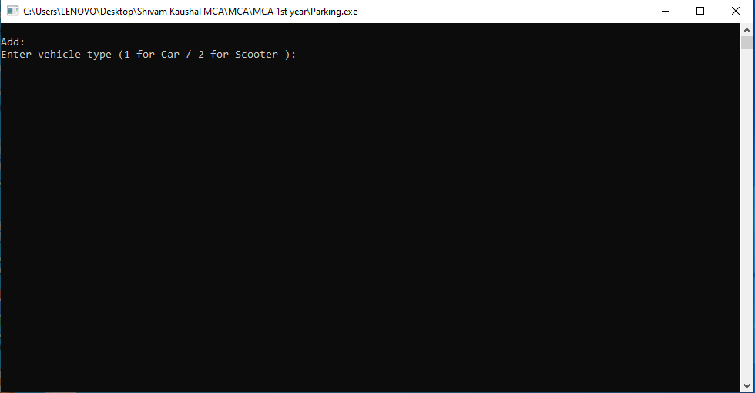

**Security**

Security: The system security problem can be divided into four relates issues: security, integrity, privacy and confidentiality. They determine the file structure, data structure and access procedures.

System security an (operating) system is responsible for controlling access to system resources, which will include sensitive data. The system must therefore include ascertain amount of protection for such data, and must in turn control access to those parts of the system that administer this protection. System security is concerned with all aspects of these arrangements.

* + System Integrity

State of a system where it is performing its intended functions without being degraded or impaired by changes or disruptions in its internal or external environments.

That condition of a system where in its mandated operational and technical parameters are within the prescribed limits. The state that exists when there is complete assurance that under all conditions an IT system is based on the logical correctness and reliability of the operating system, the logical completeness of the hardware and software that implement the protection mechanisms, and data integrity.

Confidentiality, integrity and availability, also known as the CIA triad, is a model designed to guide policies for information security within an organization. The model is also sometimes referred to as the AIC triad (availability, integrity and confidentiality) to avoid confusion with the Central Intelligence Agency

# Validation Checks

|  |  |  |
| --- | --- | --- |
| Attributes | On Module/Page | Validation |
| Select An option | Select Option | Should Not Be Null |
| Vehicle Details | Update Vehicle details | Must be Retrieved from the database |
| Customer details | View Customer details | Should retrieve from the database |

**Testing**

Testing is a process to show the correctness of the program Testing is needed to show completeness, it improve the quality of the software and to provide the maintenance aid Some testing standards are therefore necessary reduce the testing costs and operation time Testing software extends throughout the coding phase and a represents the ultimate review of configurations, design and coding Based on the way the software Reacts to these testing we can decide whether the configuration that has been built is study or not. All components of an application are tested, as the failure to do so many results in a series of bugs after the software is put to use.

# Black Box Testing

Black box testing, also called behavioral testing, focuses on the functional requirements of software. This testing approach enables the software engineer to derive the input conditions that will fully exercise all requirements for a program. Black box testing attempts to find the errors like

* Incorrect or missing functions
* Interface errors
* Errors in data structures or external database access
  + Behavior or performance errors
* Initialization and termination errors

# White Box Testing

White box testing is also called Glass box testing is a test case design control; structure of the procedural design to derive test cases using White box testing method, the software engineer can derive the test cases that guarantee that all independent paths within the module have been exercised at least once. Exercise all logic decisions on their true or false sides. Execute all loops at their boundaries and within their operational bounds. Exercise internal data structure to ensure their validity.

# Future Scope of Project

This is the modem age. Many people have vehicles. Vehicle is now a basic need. Every place is under the process of urbanization. There are many corporate offices and shopping centers etc. There are many recreational places where people used to go for refreshment. So, all these places need a parking space where people can park their vehicles safely and easily. Every parking area needs a system that records the detail of vehicles to give the facility. These systems might be computerized or non-computerized. With the help of computerized system we can deliver a good service to customer who wants to park their vehicle into the any organization's premises.

## Enhancement to create a Bigger and Better System

These enhancements deal with what would be required in a new improved, bigger and better system

. In future if when a vehicle enters into the parking area there should be one sensor in which the user can easy identify from outside only Is there parking is full or empty or space is allocated.

. In future the vehicle can be parked by machines

# E R Diagram

The first step in the development of the Vehicle Parking Management System is to prepare the ER diagram that will serve as the basis later on in the creation of the actual database.

We will create and explain the process of making the entity relationship diagram of Vehicle Parking Management System.

Let’s start from the symbols used in the ER Diagram.

Entity is represented by the rectangle shape. The entity will be our database table of Vehicle Parking Management System later on.

Attribute is represented by the oval shape. This will be the columns or fields of each table in the Vehicle Parking Management System.

Relationship is represented by diamond shape. This will determine the relationships among entities. This is usually in a form of primary key to foreign key connection.

We will follow the 3 basic rules in creating the ER Diagram.

1. Identify all the entities.
2. Identify the relationship between entities and
3. Add meaningful attributes to our entities.

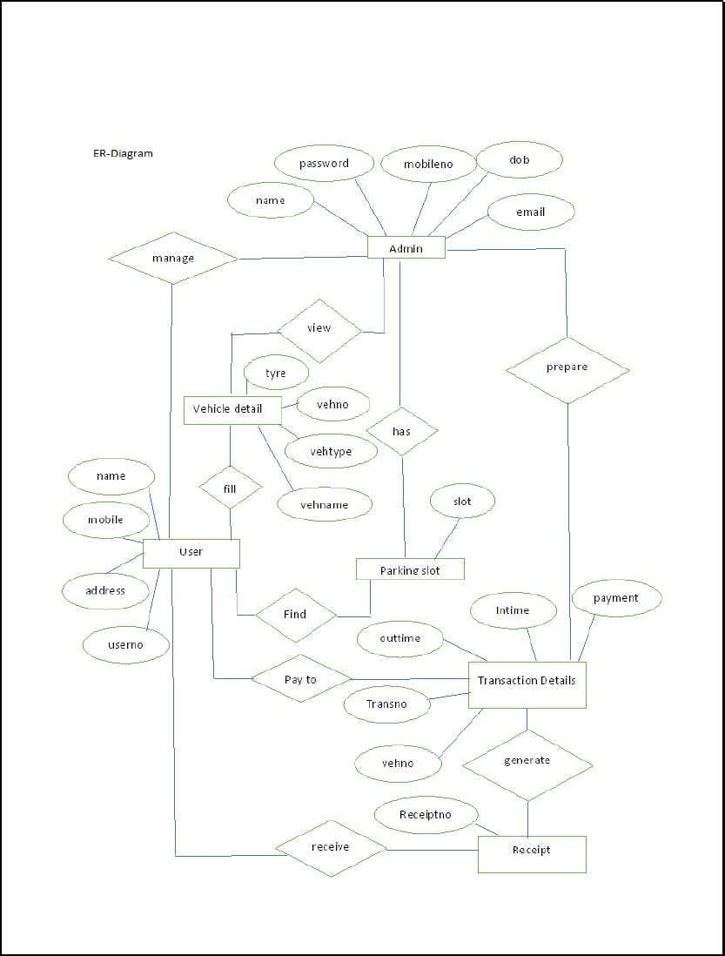

# Data Dictionary

Start

|  |  |  |  |
| --- | --- | --- | --- |
| Field | Description | Type | Constraints |
| Select Option | Either 1 to 5 | Int(5) | Not Null |

Enter Type

|  |  |  |  |
| --- | --- | --- | --- |
| Field | Description | Type | Constraints |
| Select Option | Either 1 to 3 | Int(5) | Not Null |

Select Row

|  |  |  |  |
| --- | --- | --- | --- |
| Field | Description | Type | Constraints |
| Select Option | Either 1 to 5 | Int(5) | Not Null |

Exit

|  |  |  |  |
| --- | --- | --- | --- |
| Field | Description | Type | Constraints |
| Select Option | 2 | Int(5) | Not Null |

# Area of Improvement

There are multiple areas in current situation that need improvement that are follows:

* Storing Record of entered vehicles and spaces for parking.
* Making Software based on electronic data so that it can became volatile and feasible.
* Making System feasible so that it shows current updated record of parking.
* A lot a particular space for vehicles.
* To solve problem of space availability.
* To make parking available at every needful place.

# Background of Organization

CSJM Parking is in CSJM University. It is equipped with no security with a wall, Students/Visitors Park their own vehicles with unnecessary order so the problem arise that it stuck others vehicles also.

So there needed a system to manage that all that which vehicles entered, when exited, how much space are vacant, how much filled etc.

We have no system that will also make a space to park vehicles and arrange cost also for security of vehicles.

We have no system so we can maintain data of persons who have permission to store vehicles, who are students, who is visitor etc.